Title: Depot Delta
Other Title options
- Operation Backbone
- Tactical Freight
- Depot Delta
- Cargo Crucible
- Battlefield Bureau
- Supply Line: Dead Zone
- Last Convoy
- Deadlock Dispatch
- Zero Hour: Supply Crisis
- Quantum Freight: Red Zone

Company: AJ West

Splash art
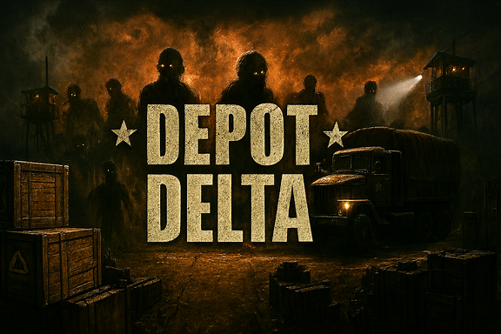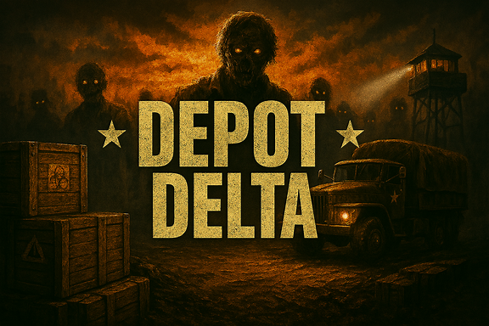

Tagline/Hook
Tagline – “Outrun the outbreak. Outlast the war
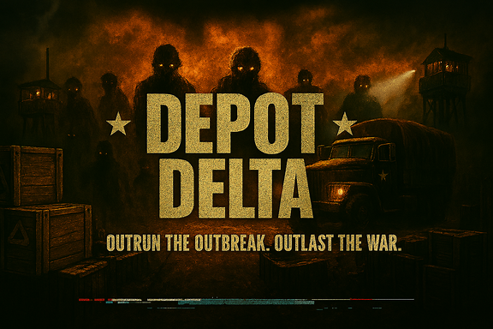

Contents
Table of Contents
Title: Depot Delta 1
Company: AJ West 1
Splash art 1
Tagline/Hook 1
Contents 1
Introduction 3
Summary/Pitch 3
Inspirations 3
Player Experience 4
Platform 4
Software 4
Genre 4
Target Audience 4
Concept 4
Core Loop 4
Themes 4
Primary Mechanics 5
Secondary Mechanics 5
Tertiary Mechanics 5
Combat 5
Puzzles 5
Quests 5
AI / NPCs 5
Special Systems 5
Progression 5
Story 5
Narrative 5
Characters 6
Dialogue 6
Storyboards 6
Art 6
Design 6
Visual Effects 7
Lighting 7
Animation 7
Audio 7
Music 7
Sound Effects 7
Voice Acting 7
Game Experience 8
UI / UX 8
Controls 8
Menus 8
Diegetics 8
Integration 9
Market Requirements 9
Priorities: 9
Minimum Viable Product 9
Stretch Goals 10
Delivery 10
Marketing 10
Post-Launch 10
Technical Requirements 10
Known Issues 10
Systems 10
Work Packages 11
Tasks 11
Activities 11

Introduction

Summary/Pitch
Focus on gameplay mechanics over narrative
Depot Delta is a Real Time Strategy (RTS) game where you need to manage your resources and personnel to survive incoming waves of zombies. Your supply lines are crucial as this is how you will restock units that are keeping the hordes at bay. With limited survivors and resources to begin with you can adventure to find more but then need to consider how you will return them to the depot so they can help you in the fight. Personal once damaged will need to be rescued by medical units creating a balance of keep fighting or retreat to fight another day as once you lose a unit it is lost for good.

Inspirations
- Other games
- Non-games (movies, music, life experiences)
The main inspiration for this game is during my placement year within the MoD I was involved with a variety of logistic based wargames. This made me think about my experience of RTS games such as Call of war, company of heroes or Planetary annihilation titans. In these games you have a central pool of resources you can use anywhere where in the wargames we had to balance combat with ensuring resources were brought to the units and it added another layer for the enemy to target. I feel as though this could add a layer to RTS games that isn’t currently there.

As I also spent time on placement learning about medical supply lines it was tough as it was not always possible to save everyone, and tough choices had to be made. In most RTS games losing a unit means little other than losing ground as you can make a new one of that unit, but I plan for units to be a resource for the player to manage and grow attached to. Forcing them to try and hold the line as long as they can or at least decide when loses are too much to justify the gain.

There are a variety of video games I really enjoy but you must play online against other people. This can be frustrating as it makes entry to these games quite difficult so as a bit resident evil fan I thought a single player mode surviving waves of zombies and other monstrosities would add a good starting point for new players. Allows for learning mechanics as well as creating a unique experience for experienced players.

Player Experience
What should players feel when they play your game?
Players should feel like they are the commander of depot delta and every unit that gets sent out the consequences fall onto the player. They should grow attached and ensure that they try to keep as many alive as they can. There should be an element of panic as your units are made to retreat, and the horde grows ever closer to the safe haven. Patients will be key as the player will have to balance expansion and survival. It will be a steep learning curve but one that shouldn’t frustrate the player as they learn more about the game.

Platform
Console, PC, Mobile, Web, etc.
This game will only be available on PC due to the complexity of the game.

Software
- Engine
- APIs for art, sound, etc.
Game engine: Godot or a custom engine made in C++ with SDL/OpenGL
Art: Aesprite and Krita
Music/Sound effects: Beep box
Additional help: Microsoft copilot

Genre
Horror, Fantasy, Metroidvania, Platformer, Shooter, etc.
The main genre of depot delta is RTS. The focus of the player should be how are they going to survive the longest by managing their resources. They could try and expand quickly to potentially find more resources and create a bigger buffer from zombies to their main base. Or they could conserve resources to keep a more focused defense potentially lasting longer because of it. There is a horror aspect of my game with the zombies and having to try and survive them as long as you can.

Target Audience
- Ideal or typical player
- What do they think? Look like? How do they act? Demographics and location? Age range?
- What other titles do they already play?
This game is design to be for players of age 18+ who are looking a more mentally challenging game to play. A player should be able to play this game for an extended period as each game should last up to a couple of hours. Players who are already experienced with real time strategy games such as company of heroes should be able to adapt to most of the basic mechanics of this game quickly.
Alternate use of this game is to get people to begin to think about the logistical side of warfare. The zombie’s element may not be realistic but the manage of resources will be. This also links into future plans to convert the game into a multiplayer experience.

Concept

Core Loop

- What will the player be doing over and over and over again?
The main aspect of the game will be the player having to control supply routes to each of their units. They will need to draw paths for their convoys to take as well as designate what resources are in what convoy and making sure the convoy is appropriate for the resources being taken. E.g. medical supplies need to be chilled so need a vehicle that can provide this. The units being resupplied will need to travel out further to find more resources as there is only a limited supply. Run down buildings being found out in the world can be used to create a continuous resource such as an oil refinery providing continuous fuel. Alternatively a hospital may give you an instant one time increase of medical supplies.
The reason you need to mange resources is to keep the zombies at bay from depot delta (your main base). This involves needing to decide when to send your units to explore or increase the width of defence and when to retreat your units. This aspect of the game is similar to a more traditional RTS game.

Themes

- Motifs and concepts that permeate the game (literal or metaphorical)

Primary Mechanics
The primary mechanic within the game is the ability to manoeuvre both units and resources around the map. Each building, unit and convoy will have a resource consumption rate and current number of resources. If they run out of resources different consequences will happen e.g. vehicles will stop moving if out of fuel or units will slow and become ineffective without DoS.

Secondary Mechanics
Due to resources being limited the player will need to explore the world to find more. This can come in a variety of ways such as buildings containing supplies or finding survivors. Your limited resources include limited personnel so exploring is a first step towards the player expanding their survival. Exploration further adds to the players logistical struggle as sending a team of scouts requires them to be stocked up enough to explore and make it back or are you banking on them not making it back and instead rather just hoping they find their own way.

Tertiary Mechanics

Combat
Combat will be simple as each unit/ building will have its own way of fighting. The basic gun unit for example will fire at the closest zombies to them every time they reload. Different units will have different ranges they can fire. Some units will also have melee capability but this is risky due to meaning the zombies will have to get close to them to attack. Combat uses resources so the player must ensure units remain stocked to be able to combat the oncoming hordes.

Puzzles
N/A

Quests
SURVIVE

AI / NPCs
Zombie types:
Baisc zombies:

Brute zombies:

Quick zombies:

Survivor types:
Hostile survivors: - likely out of scope

Friendly survivors:

Special Systems

- Mechanics particular to your game not covered above requiring elaboration (e.g. weather, schedules, day-night cycle)
Day-night cycle will be a way to allow the player to have a small reprieve with Zombies being for aggressive at night while the day is a better time to resupply ready for the onslaught to come.

Progression

- How the player will advance over the course of the game

Skill based progression

Progress by expanding your survivor community

Story

Narrative

- Outline major plot points
- Beginning, middle, end
- Conflict

Characters

- Names, descriptions, quirks
- Strengths and weaknesses
- Motivations, desires
- Relationships
Survivor types:

Dialogue

Storyboards

Art

Design

- 2D, 3D, 2.5D
- Pixel art, hyperreal, cel-shading, vector
- Concept art
- Character designs
- Level designs

Visual Effects

- Particles, widgets, emojis

Lighting

- Texture mapping, dynamic lighting, shaders

Animation

Audio

Music

- OST, adaptations, fanfare

Sound Effects

Voice Acting

- Singing
- Dialogue
- Cinematics
- Grunts and gibberish

Game Experience

UI / UX

- Style
- Flow
- Layout

Controls

- Gamepad, mouse & keyboard, touch, VR
- Button remapping
- Accessibility

Menus

- Start, pause, options
- Chat rooms
- HUDs
- Overlays

Diegetics

- In-world elements that teach the player how the game works

Integration

- Streamer modes
- Tooling
- Multiplayer
- Timers
- Achievements
- Game Modes
2 game modes being single player zombie survival and multiplayer 1v1. Considering coop multiplayer with 1 player controlling logistics and the other on the units.

Market Requirements

Priorities:

- Must Have : This item needs to be present to hit market
- Should Have : This item ensures product is the expected quality amongst its peers
- Could Have: this item will increase attractiveness of the product
- Want to Have: This item would be great to have but could have a disproportionate cost

Minimum Viable Product

- Outline what the game will look like if all core features are implemented
Core mechanics required for MVP:
Resources:
For the MVP the player has unlimited of each resource. Resource amounts will slowly increase. The resources however will only increase at your main depot so you need to then relocate the resources to where they can be best utilised.
- Personnel
  - To create a new unit, you need to spend personnel to go into that unit
  - Losing personnel within a unit will decrease the effectiveness of that unit
  - The less personnel left in a unit the less resources it requires
- Ammunitions
  - Used for units to be able to fight against enemies
  - Running out of ammunition makes a unit defenceless until it restocks
- DoS (Days of supplies)
  - The food, water etc a unit requires a day consumed at a fixed rate every x hours
  - Running out will decrease the efficiency of the unit (e.g. slower movement speed or fire rates)
    - The longer it has been out of DoS the more inefficient it becomes
  - After 3 days with no DoS the unit dies
- Fuel
  - Is used when a unit is moving
  - When a unit is out of fuel movement speed is significantly decreased
    - No fuel mean vehicles cannot be used
Player:
- Camera
  - Can use the wasd keys to move around the map
  - There will be a minimap to show the location of all the users units
- Units
  - Be able to select a unit
  - Set a destination for the selected unit to move to
  - Hovering over a unit shows its current resources
  - Can use to convoys to increase or decrease the resources of a unit
  - Units can recognise and fire at enemy units/zombies
  - Upon running out of a resource a unit will have negative effects applied to it
  - Able to create a new unit at the depot with a default set of resources assigned to it
    - New units resource stats will be those required to make it
    - Creating a unit will take a small amount of time
  - Visual cue when running low on a resource
  - Visual and sound cue when being attacked
- Depot
  - Continuous increase of all resources
  - Will have health the enemy units can damage
    - If health reach zero the player loses
  - All units will be generated at the depot
  - All convoys will be generated at the depot
  - Visual and sound cue when being attacked
- Convoys
  - Defenceless
  - Convoy health is the value of its cargo
    - Getting hit loses cargo
    - If out of cargo the convoy is destroyed
  - Convoys can be attacked by the enemy
  - Can only have a set amount of convoys outside the depot at a time so must be returned to the depot
Day-night cycle:
- Each hour lasts 1 minute
- DoS is used up at the required intervals of the day night cycle
- Visible indication of the time
  - In game clock
  - At night screen darkens and day it brightens
Enemies:
- Zombies
  - Basic zombies only
  - Continuously moving towards the closest unit/depot of the player
  - When killed despawns
  - Limited health pool
  - Continuously spawning new waves of zombies
  - Can damage player units/depot when close enough to them
- Player enemy
  - Is the same as the player
  - Units target the closest opposition unit/depot
Art for MVP:
- Basic artwork representing what the units are without any animation
- Visual indicators for what is attacking what e.g. red line joining a unit and what it is firing at.
- Depot just a define area with the delta symbol
- Background will be a basic wasteland colour palette with minimal details
Sound/Music of MVP
- Basic continuously looped music track
- Sound effects for selecting and moving a unit to help the player know what they are doing
- Sounds when zombies begin attacking a unit
- Sounds for zombies attacking the depot

Stretch Goals

Delivery

Marketing

Post-Launch

- Things to consider after launch
- Feedback
- Bug Fixing

Technical Requirements

Known Issues

- Existing problems, bugs, limitations, challenges

Systems

- Complex macro elements that need to be built and which require further depth and planning of their own
- Discrete modules that can be built in isolation and swapped in or out like components
- Weather, day-night, schedules, inventory, health, pathfinding, character creation, etc.

Work Packages

- Discrete milestones or phases of the project
- Overlay and test each before moving on to the next
- Prototype pass, gameplay pass, story pass, polish pass, demo pass, release pass, etc.

Tasks

- Individual domains assigned to each team member
- Scope and specialization
- Accountability metrics
- Target goals and requirements

Activities

- Daily or weekly goals within each task
- Outline production timeline

